Advice rapport

**Project:** Hyster-Yale

**Date:**  8-6-2023

**Auteur:** HGY Eindhoven

**Name:** Jort Van Maldegem, Simon van de Pas, Ogbeide Osayewenre, Adam Wiszniowski-Świder, Toma Krastanov

**Semestercoach:** Suzana Andova

​​

​

​

Introduction 4

Company description 4

Stakeholder analysis 5

Problem 6

Research questions 7

Main question 7

Looking at both the dashboard and the Netpresenter, what information should be displayed and how can we automate the process? 7

Sub-questions 8

What should be on the dashboard? 8

What should be on Netpresenter? 9

What formats can be put on Netpresenter? 9

How is truckdata being gathered and stored? 10

Solution 11

User Guide 14

Recommendations 15

Conclusion 17

# Introduction

In today’s fast-paced and increasingly digitized business landscape, companies are realizing the immense potential of harnessing data to drive innovation, streamline operations and gain a competitive edge. As technology exponentially advances, it is crucial for companies, like Hyster-Yale to adapt and embrace digital transformations to maximise efficiency and succeed in upcoming opportunities.

This document hopes to present a compelling case for Hyster-Yale Group to implement the proposed solution for digitalising their date in a more efficient manner. By centralising its data, Hyster-Yale might be able to improve their operations, development, and overall business performance. The improvements to the current way of displaying the data, might be to enable real-time access to accurate and up-to-date information, allowing for quicker decision-making. By elimination manual and time-consuming processes, employees can focus on, more, value-adding activities, leading to increased productivity and efficiency across the organisation. Furthermore, by improving the digitalisation of the data, Hyster-Yale will gain their valuable insights more quickly. By leveraging the analytical tools, Hyster-Yale can identify patterns, trends, and correlations within its data.

This document will also go over the collaboration between the data and Netpresenter. The implementation of a robust data digitalisation solution will also enhance collaboration and communication within Hyster-Yale Group. With a centralised digital platform, which is visible throughout the entire company site, employees from different departments and locations can easily view the information, fostering a culture of collaboration. This streamlined flow of data will encourage knowledge sharing and promote innovation throughout the company.

Moreover, giving the customers of Hyster-Yale access to the data of their own trucks, will significantly improve the customer experience at Hyster-Yale. Real-time insights into customers will also allow Hyster-Yale to proactively anticipate and address the needs of their clients. Building stronger relationships and increasing their loyalty.

Lastly, the digitalisation of data will position Hyster-Yale Group as a forward-thinking industry leader. Embracing digital transformation displays the company's commitment to innovation, adaptability and staying ahead of the competition. Like Ravinder Singh ones said: *“If you do not innovate, you will stagnate.”*

# Company description

Hyster Yale Group is a global company operating in three separate segments: Lift Trucks, Attachments, and Fuel Cells. With 19 manufacturing operations in 12 countries and over 90 years of experience in the materials handling industry, the company has built a solid reputation. The company was founded in 1840 by Linus Yale Sr. and has since had a long history of success and innovation. Hyster Yale Group specializes in delivering robust lift trucks that meet the needs of customers and enhance the potential of their partners. Hyster Yale's lift trucks have lifting capacities ranging from 900 to 48,000 kilograms. They are characterized by award-winning designs, industrial-strength components, and high-tech manufacturing, resulting in versatile and reliable solutions that meet the diverse requirements of customers.  
In addition to lift trucks, Hyster Yale Group also has subsidiaries, including Bolzoni S.p.A. This is a leading global producer of attachments, forks, and lift tables marketed under the Bolzoni®, Auramo®, and Meyer® brand names. The group also includes Nuvera Fuel Cells, LLC, a company focused on alternative power technology, particularly fuel cell stacks and engines. Hyster Yale Group also has an unconsolidated joint venture in Japan called Sumitomo NACCO, which strengthens the company's presence and operations in the Japanese market.  
With its global presence, extensive product range, and focus on quality and innovation, Hyster Yale Group remains a key player in the materials handling industry, creating value for customers and partners worldwide.

## Stakeholder analysis

Stakeholders play a vital role in shaping a successful and sustainable organisation. These groups or individuals have an interest or influence in the outcomes of an operation. Understanding these stakeholders and knowing what their roles are, is crucial for organisations to make informed decisions. Therefore, the stakeholder analysis is a powerful tool to an organisation to better understand and engage with the diverse range of stakeholders. Effective stakeholder analysis involves systematically identifying and categorising stakeholders, assessing their level of interest and influence, and determining their potential impact on the organisation.

**Hyster Yale**  
What are the concerns of the stakeholder?

*Hyster Yale's biggest concern is whether the investment of hiring the consultant firm is worth it.*

What are the expectations of the stakeholder?

*Hyster Yale has the expectation that based on the dynamic dashboard employees and clients get more insight in the trucks and daily activities.*

What for interest has the stakeholder?

*Hyster Yale has a fair amount of interest because if this project succeeds there will be a better insight in reliability and truck data in the same place. Which means that it is easier to make decisions on facts.*

What power has the stakeholder?

*Hyster Yale has a lol of power, it finances this project as well. This means that the project can be stopped at any moment.*

**Clients of Hyster Yale**

What are the concerns of the stakeholder?

*The biggest concern of the clients is of the dashboard shows the right data and if it the dashboard is thrust wordy.*

What are the expectations of the stakeholder?

*Hyster Yale's client are expecting a dashboard that gives them more insight into their truck data.*

What for interest has the stakeholder?

*The clients of Hyster yale have some sort of interest in this project because it could give them more insight about their truck data.*

What power has the stakeholder?

*The clients of Hyster Yale have some power. Because they are customers, but this does not mean that Hyster Yale must obey to everything that the clients want.*

**Remko Sengers**

*What are the concerns of the stakeholder?*

*The biggest concern of Remko Sengers is that the dashboard works and gathers all the right data, so it simplifies his work.*

What are the expectations of the stakeholder?

*Remko's expectations of the dashboard are that it automates a part of his job, so he gets to focus on other things as well.*

What for interest has the stakeholder?

*Remko is interested in the project because it would simplify his job.*

What power has the stakeholder?

*Remko has a lot of power. Because he knows the how and abouts of this job as no one else. Remko gets to decide what is on the dashboard and what is not.*

# Problem

As every global company Hyster Yale wants to expand and improve their services and products. To achieve that however, a strict monitoring of certain KPI’s is required. Currently whenever a data of truck performances is required, it is manually plotted by an employee. To eliminate human factor and automate a process we propose a solution in a form of automated dashboard, plotting all KPI’s regarding truck data in one place. Centralising the data by doing this we can not only free an employee of an unnecessary task, but also allow for a better information distribution by providing managers, selected employees, and clients with various levels of access. Additionally live data input will allow for a quicker and more effective analysis of insights, leading to better understanding of processes and increased productivity. By restraining from performing any changes from its current form of extracting data, Hyster Yale exposes itself on potential oversight of potentially significant changes within the truck performances.

**SPA analysis**

**What is the problem?**

All performance graphs, and calculations are performed manually, when necessary, instead we propose to automate the process with use of powerbi  
When does the problem occur?

When quick analysis is needed it needs to be prepared instead of displaying automatically

**Why is it a problem?**

Every time someone would like to see current data analysis, an employee would have to plot current data to get latest status.

**Why does the problem need to be solved?**

For better performance analysis a dashboard displaying live data, would be much more practical than sprint-based analysis separately created each time by an employee

**What is the cause of the problem?**

Lack of implementation of similar tool by HYG

**Who is affected by the problem?**

An employee that is responsible for plotting data, as well as every person who would need to see the dashboard

# Research questions

Research questions play a pivotal role in the exploration of innovation. They serve as the foundation upon which research projects are built and provide a clear segmented approach to the solution. Research questions are designed to identify gaps in knowledge, address existing problems or challenges and create insights in the current problems. Research questions consist of a main question which will be answered with the answers to the several sub questions. These sub questions serve as a roadmap, ensuring that the research undertaken is purposeful, focused and contributes meaningfully to the existing knowledge. In this chapter, you will be able to read about the research questions regarding this project.

Main question

### Looking at both the dashboard and the Netpresenter, what information should be displayed and how can we automate the process?

**1. Determine the Relevant Metrics:** Identify the key metrics and data visualization that you want to display on the Netpresenter. These could be important KPIs (Key Performance Indicators), performance indicators, or any relevant data that needs to be displayed.

2. **Design an Effective Dashboard**: Create a well –designed PowerBI dashboard that present the required information in a visually appealing and easily understandable format. Ensure that the dashboard provides a real-time or near-real-time updates to keep displayed information current.

3**. Data Integration:** Establish a Data Integration process between Power Bi and Netpresenter. This can be achieved by leverage the available API's or connector provider by both platforms. You may need to develop custom scripts or use third Party tools to facilitate the integration.

4. **Automate Data Refresh:**  Configure automate Data Refresh in power BI so that dashboard is updated with the latest data at regular intervals. This ensures that the displayed information on Netpresenter remains up to date without manual intervention.

**5. Publish the Dashboard:** Publish the Power BI dashboard to a shared workspace or embed it in a web page or portal accessible to Netpresenter. This allows Netpresenter to fetch and display the Power BI dashboard as part of its information rotation.

6. **Netpresenter Configuration: S**et up Netpresenter to cycle through the available information screens, Including the Power Bi dashboard. Configure the time duration for each screen to be displayed, transition and any other desired settings.

7. **Display Challenges:** There may be few challenges when displaying information from Power BI to Netpresenter.

**Compatibility:** Ensure that the Netpresenter support the Method or format in which Power BI dashboard is published or embed. Check if any customization or adjustments are required for seamless integration.

**Data Security:** Consider any Data security or access restrictions that may apply to the Power BI dashboard. Ensure that the integration from the Netpresenter adhere to the necessary security protocols and permissions.

**Network Connectivity:** Ensure that the System running the Netpresenter has a stable and reliable network connection to fetch and display the Power BI dashboard. Any disruptions in connectivity could impact the displayed of real-time data.

**Display Resolution and Scaling:** Adjust the Power BI dashboard and Netpresenter settings to ensure a proper resolution and scaling for the target display screens. This ensures that the information is legible and visually appealing on the Netpresenter Display.

## Sub-questions

### What should be on the dashboard?

Considering data that Hyster Yale has delivered as well, as their requirements determined on meetings, the final dashboard should consist of following features.

* Reliability dashboard featuring:
  + Mean Time Between failures
  + Test Time Chart
  + Reliability Growth Chart
  + Test Time Chart
* Truck Data dashboard consisting of:
  + Resolved Failures
  + Active vs Idle Time (Pie chart and bar chart)
  + Containers Picked by Day
  + Distance Driven in meters by Day
* Individual Truck dashboard containing:
  + Mean Time Between failures
  + Test Time Chart
  + Failures

### What should be on Netpresenter?

Hyster Yale gathers various kinds of truck information including reliability data and truck data.

* Reliability data:
  + Test time
  + Failures recorded
  + Failures resolved
  + Amount of failures
  + Date
  + Test unit
  + Impact

Truck data:

* + Date
  + Session length
  + Distance driven
  + Picks per hour
  + Containers handled
  + Average speed
  + Idle percent
  + Idle time
  + Active time

Hyster Yale wants us to make a dynamic dashboard of this data. However, Hyster Yale does not want to share all the data with the whole company, only to the people it is useful for. The mechanics at the assembly line/ people who get a guided tour are not supposed to see some of the data such as what kind of failures there are.

During different interviews with Jan Willem Houwers and Remko Sengers it became clear to us that the truck data can be shared with the people on the floor, but the reliability data preferably cannot be shared.

### What formats can be put on Netpresenter?

Looking at the website of Netpresenter, the format of the hosted dashboard should be in either one of the following formats.

* Images: JPEG, PNG, BMP, PCX, GIF
* Video: AVI, MPEG1, MPEG2, MPEG4, DivX or other livestreams
* YouTube
* Websites
* Social Media like Facebook and Twitter
* Newsfeeds: XML/RSS

Currently Hyster-Yale is using both Power BI and Grafana. Both Power BI and Grafana would be possible to be used within Netpresenter. Since both can be cast with the URL and the project group has more experience with Power BI, the advice is to continue with the use of Power BI so that all the digitalization is on a centralized location.

### How is truckdata being gathered and stored?

Hyster Yale B.V a Leading manufacturer of materials handling equipment, including trucks implement various methods to gather and store truck data for their dynamic dashboard. Regarding Hyster Yale's implementation, here is a general overview of how truck data is typically gathered and stored using platforms like Power BI or Grafana:

**Gathering Data:**

1. **On-board Telematics Systems:** Hyster Yale trucks may be equipped with on-board telematics systems that collect data from various sensors and components of the truck. These systems can capture information such as vehicle speed, engine diagnostics, fuel consumption, operating hours and more.
2. IOT Sensors: Additional sensors can be installed on the trucks to capture specific data points. For example, sensors may be used to monitor tire pressure, cargo weight or temperature inside the truck. These sensors can transmit data wirelessly to a central data collection point.
3. GPS Tracking: GPS device can be used to track location and movement of the trucks. This information can be valuable for optimizing routes, monitoring fleet performance, and ensuring timely deliveries.
4. Manual Inputs: Truck operators or maintenance personnel may provide manual inputs or complete checklists to record specific events, inspections, or maintenance activities. This data can be entered into the system manually or through mobile applications.

**Storage and Processing:**

Once this data is gathered, it needs to be stored and processed for visualization and analysis on platforms like Power BI or Grafana:

1. **Data Storage**: The collected truck data is typically stored in a database or data storage system. This can be traditional relational database management system (e,g MYSQL, PostgreSQL) or a NOSQL database (e.g MongoDB) based on the requirement sand scale of the data.

2. **Data Integration:** If data is collected from multiple sources, a data integration process may be employed to consolidate and merge the data into a single cohesive dataset. This involves transforming the data into a standardized format and resolving any inconsistencies or discrepancies.

**3. Data Processing and Analysis:** Once the data is integrated, it can be processed and analysed to derive meaningful insights. This may involve data clearing, filtering, aggregation and applying statistical algorithms or machine learning techniques to identify patterns or anomalies in the data.

Visualization and Reporting: Platforms like Poer BI or Grafana can be used to create interactive Dashboard and reports. These tools provide a range of visualization portions (e.g Charts, Graphs, Maps) that can be customized to present the truck data in a visually appealing and informative manner.

Real-time Monitoring: TO enable real-time monitoring the data processing pipeline may include components that allow for near-instantaneous updates to the dashboard as new data steams in . This ensures that the dynamic dashboard reflects the most up to data information about the trucks.

**How should the dashboard be designed to display real-time data and be more dynamic?**  
To make the dashboard more dynamic the data needs to be updated daily so that the dashboard updates as well. Since we only received spreadsheets with data, we were unable to create such a dynamic pipeline as we were not granted access to the actual database that the data we used was stored. Since we are using PowerBI we could easily connect the dashboard to a database. After brainstorming we produced a solution to create our own server that can be used to store the data and can be used to update the data (see Recommendations section). Since all we have is static data, this is only a temporary solution, and it would be most optimal for Hyster Yale to connect the dashboard to their internal servers.

**How to integrate different data sources into the dashboard and present it in a cohesive manner?**  
PowerBI has the tools to integrate different data sources at the same time into a dashboard, so it is future proof, and the dashboard can be built up on by adding more data to it (e.g., more trucks).

**How should the dashboard be designed to meet the specific needs of different departments in the company?**  
To make sure that the dashboard meets the requirements of the different departments that are going to be viewing the dashboard we conducted interviews with representatives from those departments to ensure that we can display all the data that would be needed for the people viewing the dashboard.

**How should the data be visualised to make it more digestible and easier to understand?**  
After talking with the client, we were given instructions on how the data should be displayed on the dashboard and what graphs and charts should be used. After each iteration of the dashboard, we would have meetings with the client for feedback and if anything should be added/changed. The client also provided us with so graphs that were already made and needed to be ported from Excel to PowerBI.

**How can user testing and feedback be incorporated in the design process of the dashboard to ensure the final product meets the client’s needs?**  
After every sprint we received feedback from the client on how the dashboard can be improved and what more should be added to it. That ensured an effective communication that would guarantee that the client is happy with the final product.

# Solution

Following a close communication with the client we were able to create a product that both us and the client are happy with. The dashboard consists of two main pages as well as individual pages for different trucks:

**Reliability Page**

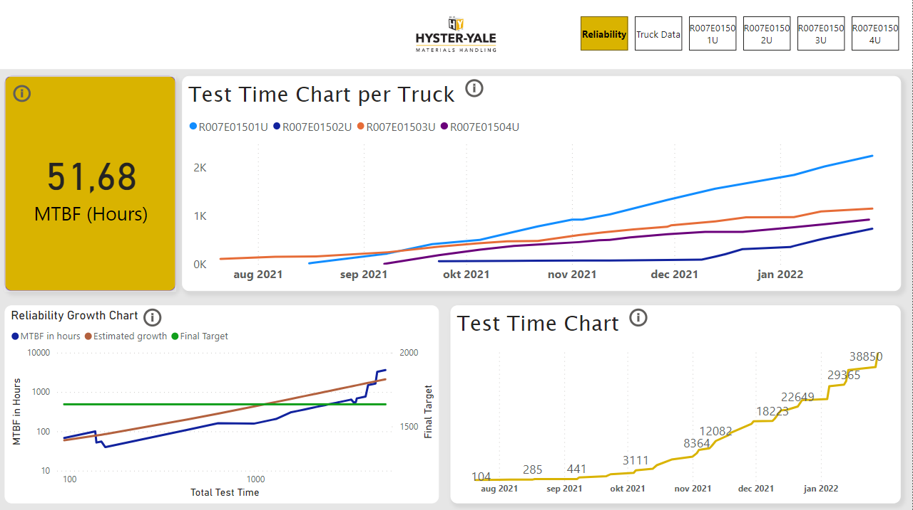

On the reliability page we show important statistics that ensure how reliable a truck is. The test time charts show how the total test time of all trucks as well as the test time of each individual truck over a certain period. The MTBF card shows the mean time between failures for all trucks which helps the customer determine how often a truck fails while on the field. The most important chart on this page is the reliability growth chart which shows how the mean time between failures develops the longer a truck is tested. This helps the reliability team figure out how trucks are performing the more time they are being tested and compare the results to the estimated growth.

**Truck Data Page**

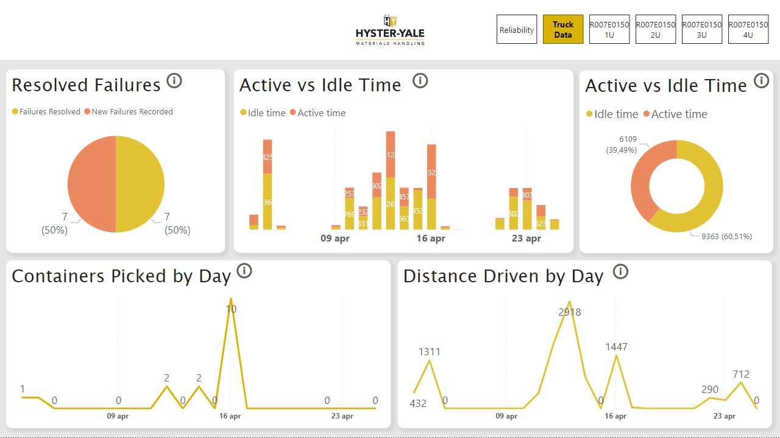The truck data page shows how all trucks are performing. We get detailed information on how much active vs idle time the trucks spend as well as the number of containers they have picked every day and the distance they have driven. We also get to see all failures that were recorded as well as whether they were resolved or not. What information this page should contain was gathered from interviewing several different stakeholders in the project as well as adapted to the client’s needs after each sprint.

**Individual Truck Pages**

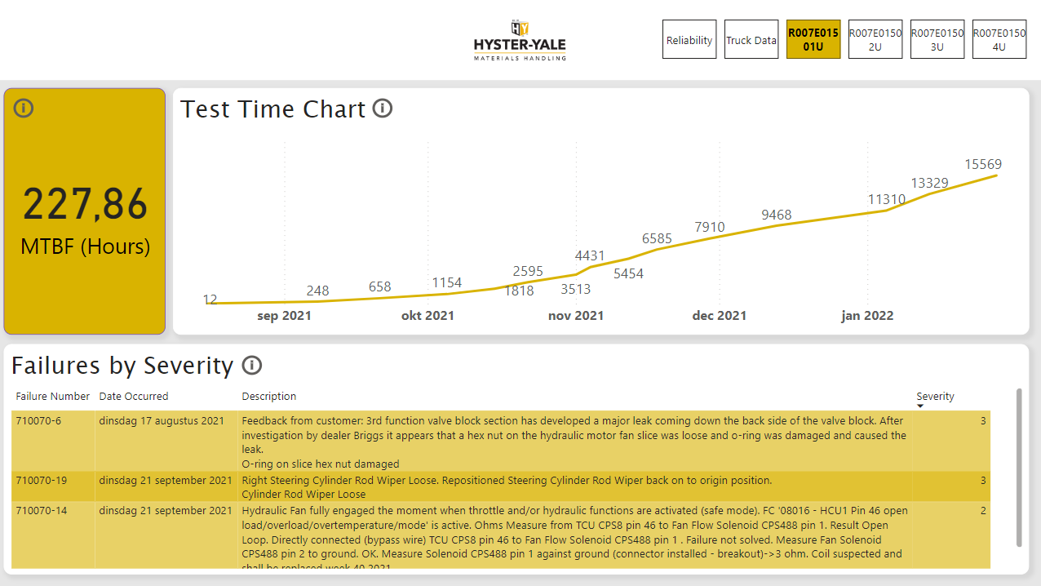Besides the reliability and truck data pages, after consulting with the client we were told to make individual pages for the different trucks. The data on those pages includes the mean time between failures for each individual truck as well as the test time that the truck has had. We also included a table showing the failures that the truck has and sorted them by the highest severity to highlight the most important failures that truck has. In that way when a new severe failure is recorded it will show up on the page and the according measures can be taken as fast as possible.

User Guide  
The explanation of the different charts and how to navigate through the dashboard shown for the different pages that we made.

**Reliability page:**

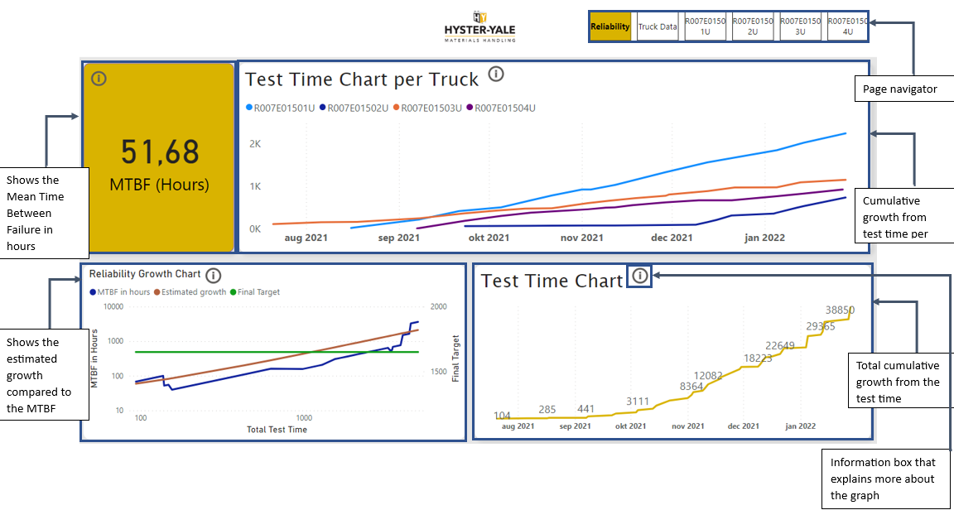

**Truck data page:**

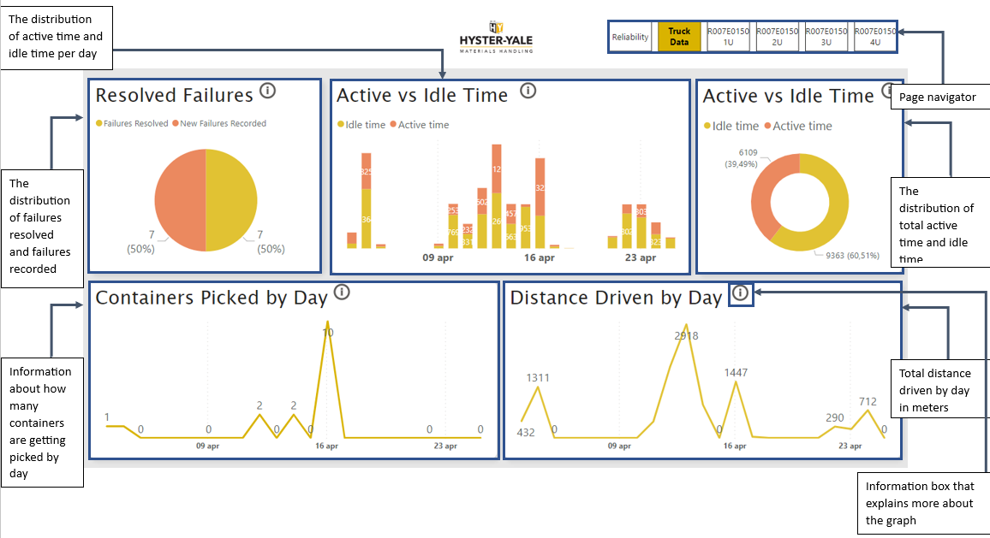

**Individual Truck page:**

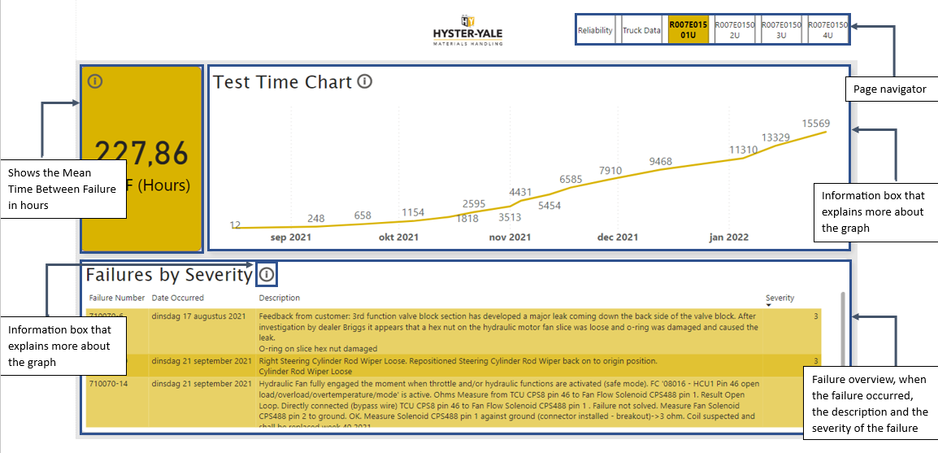

# Recommendations

We have created a way to externally store the data for the dashboard to make it easy to update the dashboard with new data. As the current dashboard is getting data from a static excel file, we believe that this would be a way to keep the dashboard dynamic and easily updateable. Another way to keep the dashboard dynamic is to connect it to the data pipeline that Hyster Yale uses but since we have no access to that, this is the solution and recommendation we have come to as a group.

In this system, we will create an external storage research system to gather and store truck data for Hyster Yale B.V Netherlands dynamic dashboard. The system will utilize a full-stack authentication app with React frontend, NodeJS and Express for the backend, MySQL as database and provide features such as

Login, Registration, logout access for system developers. Additionally, we will include functionally to update data and export it as an Excel Sheet for analysis in Power BI or Grafana. . here are the steps:

**Step 1: Set up the Development Environment**

* Install NodeJS and MYSQL on your System.
* Set up a new project directory and initiate it with the necessary dependencies using npm or yarn.
* Create the frontend and backend folders in your project directory.

**Step 2: Design the Database Schema**

* Identify the data points that need to be stored for each truck. These can include attributes such as the truck ID, location , speed, engine diagnostics fuel consumption, and more
* Design the database schema using SQL statements to create the necessary tables and define relationships between them. Use MYSQL for the purpose

**Step 3: Build the Back end**

* Set up the NodeJS SEVER USING Express.
* Create routes and controllers to handle user registration , login and logout functionally.
* Implementing authentication using techniques like JWT (JSON Web Tokwens) for secure access to the system's features.
* Create API endpoints to handle data retrieval, updates and exporting as an Excel Sheet.

**Step 4: Develop the Front-End**

* Build the user interface using ReactJS, incorporating components for login, registration, logout, and data management.
* Implement form validation and error handling
* Connect the frontend to the backend API for user authentication and data retrieval /update/export operations

**Step 5: Integrate Excel Export Functionality**

* **U**tilize Libraries such as xlsx or exceljs to generate and Exell sheet from the retrieval truck data.
* Implement a mechanism to allow users to trigger the export operation such as button or menu option.
* Handle the export request on the server –side , convert the data to the Excell format , and send it as a response to the client.

**Step 6: Integrate Power BI or Grafana Analysis**

* Set up a connection between Power BI or Grafana and the database to access the exported data or fetch it directly from the database.
* Design and configure the required graphs, charts, and dashboards in a Powe BI or Grafana to visualize and Analyse the truck data

# Conclusion

In conclusion, for Hyster-Yale to optimise their insights and work-efficiency as well as guiding their customers, it is crucial to leverage innovative tools and technologies that can enhance testing processes. Therefore, a dashboard has been developed, enabling the display of real-time data and analytics throughout the company’s site, using Netpresenter, to establish a motivational boost for its employees. By implementing the developed dashboard, Hyster-Yale can streamline its testing procedures and gain deep insight into the performance, efficiency, and functionality of their trucks. The current dashboard will be able to track the trucks failures, active/idle time, picking efficiency, distance, and its test results. By further expanding the dashboard, additional critical data points such as battery life, charging patterns, energy consumption, and maintenance requirements could be tracked. This dashboard will be categorised per project, ensuring that the reliability, overall truckdata, and individual trucks data will be visible. By doing this, Hyster-Yale will be able to assist their clients with relevant and reliable visuals.